Module 5: Critical Thinking

Bryan Moffett
Colorado State University Global
ITS410: Database Management
Dr. Raquel Hicks
September 20th, 2026

Writing Queries in My Guitar Shop Database
Task 1.3 - Count Orders and Sum Tax Amounts
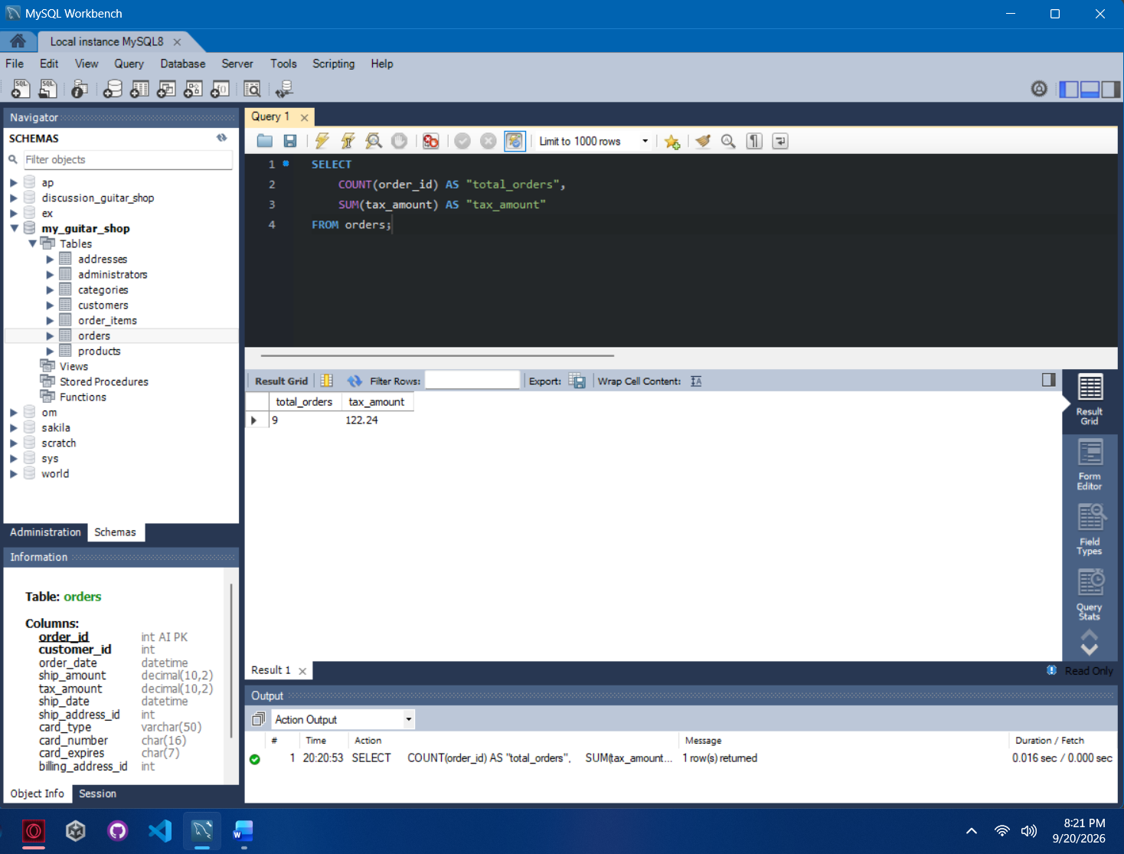

Task 2.4 - Aggregate Product Data by Category
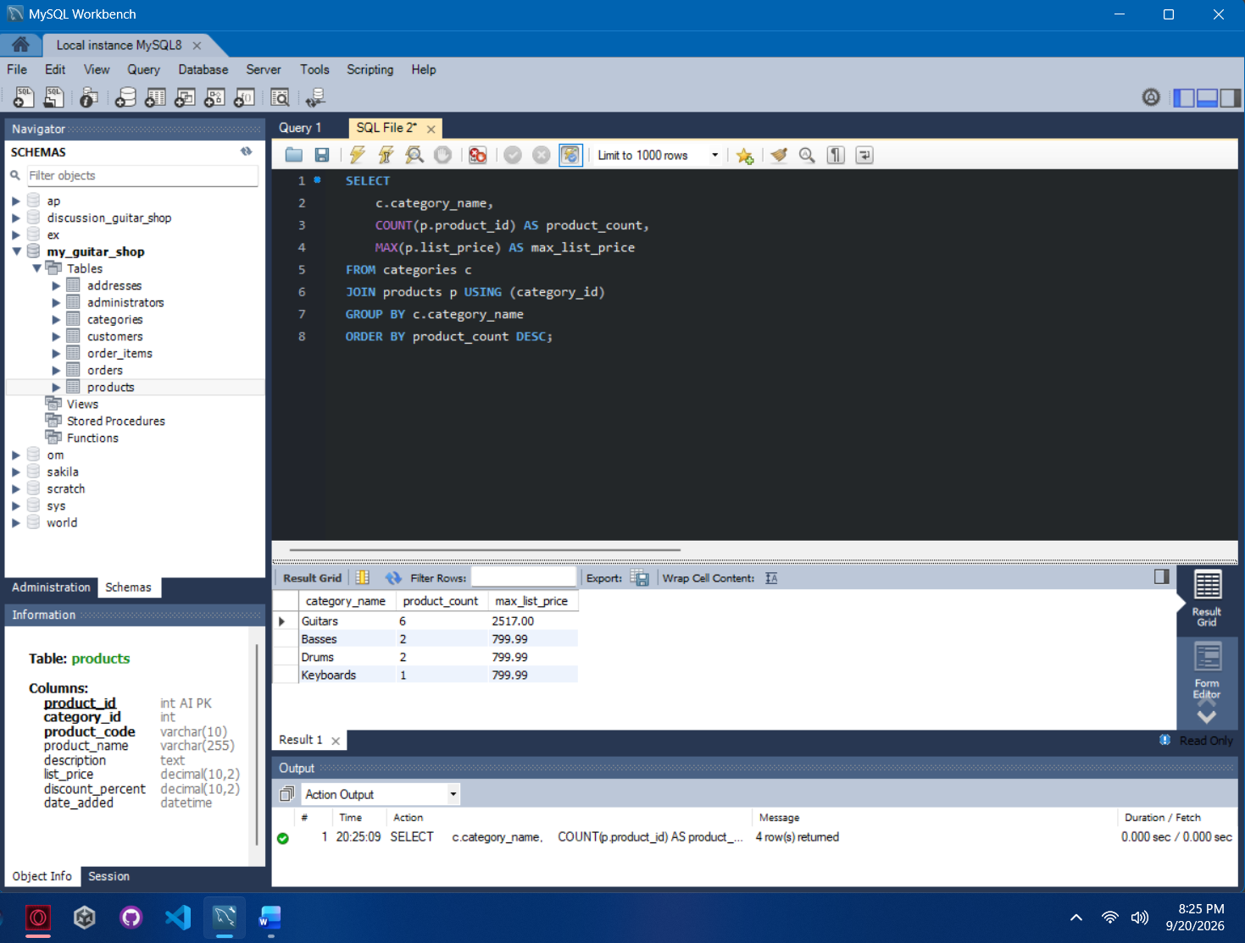

Task 3.4 - Calculate Sales and Discounts per Customer
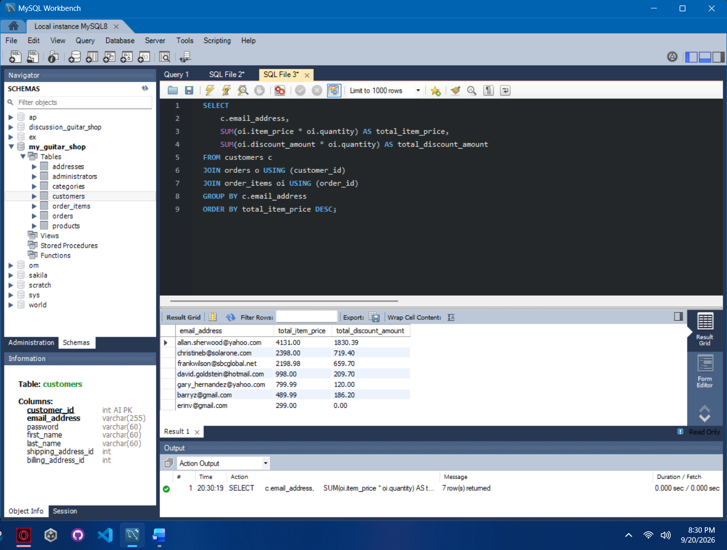

Task 4.5 - Count Orders and Calculate Total Order Amount per Customer
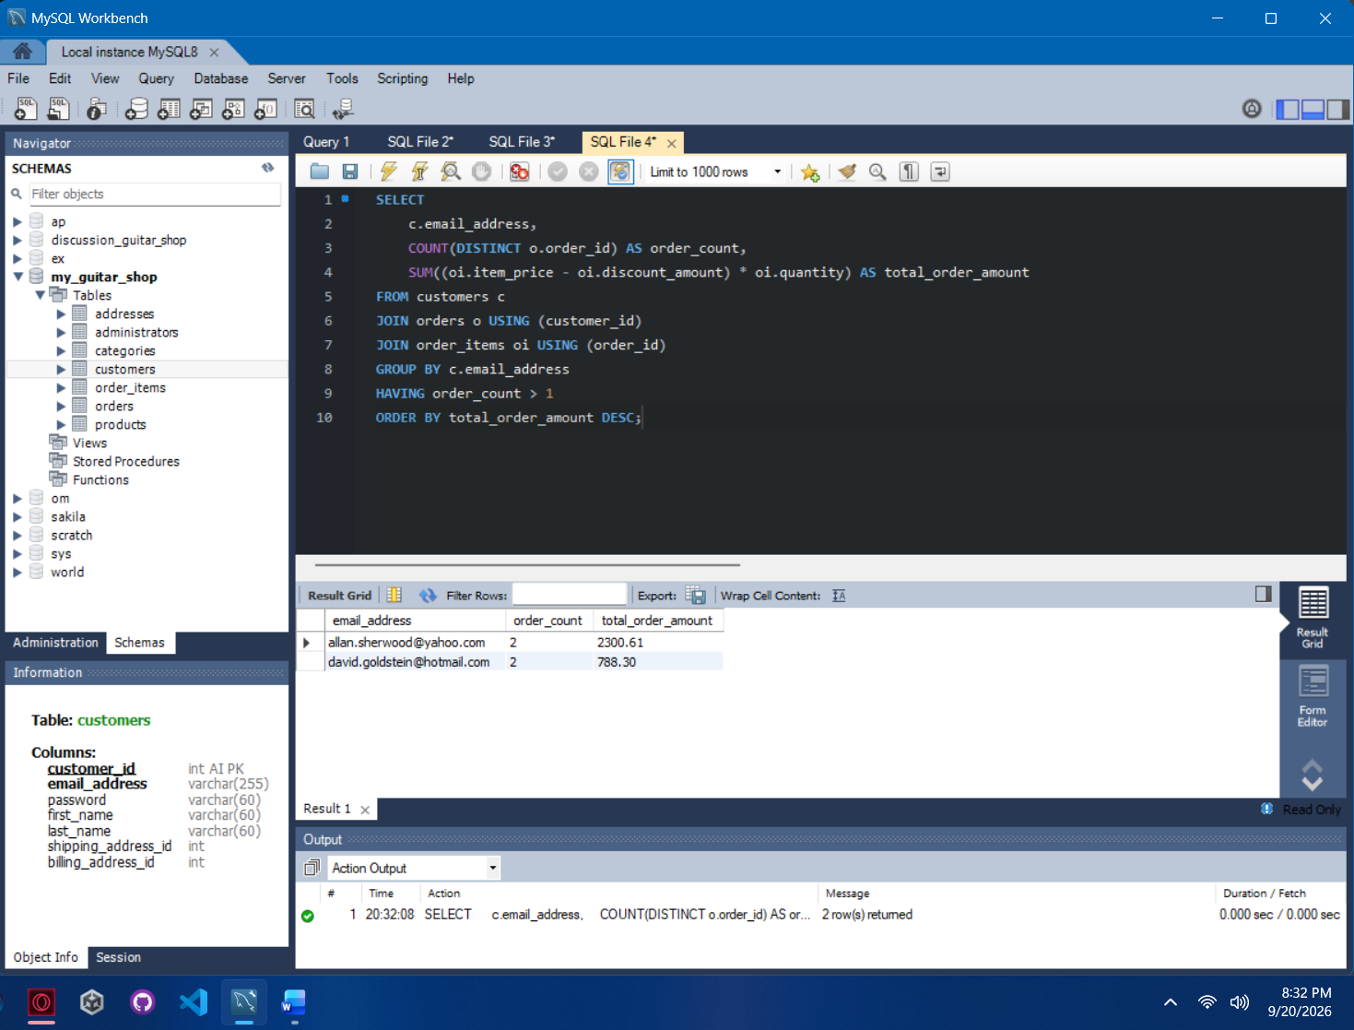

References

Murach, J. (2019). Murach’s MySQL (3rd ed.). Murach Books.

